Complaints
Policy Statement
The law requires care providers to have an effective system in place to identify, receive, handle and respond appropriately to complaints and comments made by service users, or persons acting on their behalf.
To show legal compliance the agency must:
- bring the complaints system to the attention of service users and people acting on their behalf in a suitable manner and format
- facilitate the making of complaints when one is being made
- fully investigate all complaints and (where relevant) work with other services where the complaint is of a joint nature to address the issues raised.
Where appropriate the agency will also refer users to the leaflet published by the CQC, How to Complain about a Health or Social Care Service.
This policy should be read and used in relation to other policies on:
- Service User Feedback
- Assessing and Monitoring the Quality of Service Provision
- Safeguarding Service Users from Abuse or Harm.
This care agency works on the principle that if a service user wishes to make a complaint or register a concern they should find it easy to do so. It is the agency’s policy to welcome complaints and look upon them as an opportunity to learn, adapt, improve and provide better services. This policy is intended to ensure that complaints are dealt with properly and that all complaints or comments by service users and their relatives and carers are taken seriously.
The policy is not designed to apportion blame, to consider the possibility of negligence or to provide compensation. It is not the same as the agency’s disciplinary policy. However, the agency understands that failure to listen to or acknowledge complaints could lead to an aggravation of problems, service user dissatisfaction and possible litigation.
The agency supports the principle that most complaints, if dealt with early, openly and honestly, can be sorted at a local level, ie between the complainant and the agency. If this fails due to the complainant being dissatisfied with the result, the agency respects the right of the complainant to take the complaint to the next stage by seeking a review with the relevant reviewing body of how the complaint was addressed.
The aim is always to make sure that the complaints procedure is properly and effectively implemented and that service users feel confident that their complaints and worries are listened to and acted upon promptly and fairly.
Principles of Complaints Handling
- Service users, their representatives and carers are always made aware of how to complain and that the agency provides easy-to-use opportunities for them to register their complaints.
- A named person is always responsible for the administration of the procedure.
- Every written complaint is acknowledged within two working days.
- Investigations into written complaints are held within 28 days.
- All complaints are responded to in writing by the agency.
- Complaints are dealt with promptly, fairly and sensitively with due regard to the upset and worry that they can cause to service users and those against whom the complaint has been made.
- The agency recognises national guidance on complaints handling, which uses a three stage model of:
- local resolution
- complaints review and
- independent external adjudication by Local Government Ombudsman, Health Service Ombudsman or through the Independent Healthcare Advisory Services (IHAS).

- The person to whom complaints should be made is ________________________________. (provide a named person or complaints manager).
The Complaints Procedure
Stage one: local resolution
The agency works on the basis that wherever possible, complaints are best dealt with directly with the service users by its staff and management, who will arrange for the appropriate enquiries to be made in line with the nature of the complaint. This can involve using an independent investigator as appropriate or if the complaint raises a safeguarding matter a referral to the local safeguarding adults authority.
Stage two: complaints review
In line with national guidance the agency then recognises that if the complaint is still not resolved, the complainant has a right to take their complaint to the body responsible for the commissioning of the service eg local authority and / or health service (again depending on the nature of the complaint and type of service involved).
Stage three: independent external adjudication
If complainants are still dissatisfied with the management and outcome of their complaint the agency is aware that they can refer the matter to Local Government Ombudsman / Health Service Ombudsman / in respect of some private health care providers through the Independent Healthcare Advisory Services (IHAS) for external independent adjudication.
Role of the Care Quality Commission
The agency makes its users aware that the Care Quality Commission does not investigate any complaint directly, but it welcomes hearing about any concerns. It accordingly provides users with information about how to contact the CQC by referring them to the CQC’s leaflet “How to Complain about a Health or Social Care Service” (July 2013)”, (available on the CQC website).
The agency also sends to the CQC any information about complaints requested or required as part of CQC’s compliance reviewing policy.
Safeguarding Issues
In the event of the complaint involving alleged abuse or a suspicion that abuse has occurred, the agency refers the matter immediately to the local safeguarding adults authority, which will usually call a strategy meeting to decide on the actions to be taken next. This could entail an assessment of the allegation by a member of the Safeguarding Authority team. (See the Safeguarding Service Users from Abuse or Harm policy.)
Verbal Complaints
The agency adopts the following procedures for responding to complaints and concerns made verbally to staff or to the agency’s managers.
- All verbal complaints, no matter how seemingly unimportant, are taken seriously.
- Front-line care staff who receive a verbal complaint are instructed to address the problem straight away.
- If staff cannot solve the problem immediately they should offer to get the manager to deal with the problem.
- All contact with the complainant should be polite, courteous and sympathetic. There is nothing to be gained by staff adopting a defensive or aggressive attitude.
- At all times staff should remain calm and respectful.
- Staff should not make excuses or blame other staff.
- If the complaint is being made on behalf of the service user by an advocate it must first be verified that the person has permission to speak for the service user, especially if confidential information is involved. It is very easy to assume that the advocate has the right or power to act for the service user when they may not. If in doubt it should be assumed that the service user’s explicit permission is needed prior to discussing the complaint with the advocate.
- After talking the problem through, the manager or the member of staff dealing with the complaint will suggest a course of action to resolve the complaint. If this course of action is acceptable then the member of staff will clarify the agreement with the complainant and agree a way in which the results of the complaint will be communicated to the complainant (ie through another meeting or by letter).
- If the suggested plan of action is not acceptable to the complainant then the member of staff or manager will ask the complainant to put their complaint in writing and give them a copy of the agency’s complaints procedure.
- Details of all verbal complaints are recorded in the complaints book by the staff or managers who receive the complaint and on the individual’s care records with information on how a specific matter was addressed.
Written Complaints
The agency adopts the following procedures for responding to written complaints.
Preliminary steps
- When a complaint is received in writing it is passed on to a named person / complaints manager who records it in the complaints book and sends an acknowledgment letter within two working days, which describes the procedure to be followed.
- The complaints manager / a named person deals with the complaint throughout the process.
- If necessary, further details are obtained from the complainant. If the complaint is not made by the service user but on the service user’s behalf, then consent of the service user, preferably in writing, is obtained from the complainant.
- If the complaint raises potentially serious matters, advice will be sought from a legal advisor. If legal action is taken at this stage any investigation under the complaints procedure should cease immediately pending the outcome of the legal intervention.
- A complainant, who is not prepared to have the investigation conducted by the organisation or is dissatisfied with the agency’s response to the complaint is advised to contact the organisation or organisations responsible for commissioning their services (local authority / and or health service) for a review of their complaint.
- The complainant then has the option of taking the matter to independent external adjudication and will be referred to the information provided by the CQC in its leaflet “How to Complain about a Health or Care Service” (July 2013)
Investigation of the Complaint
- Immediately on receipt of a written complaint the agency will launch an investigation and aims within 28 days to provide a full explanation to the complainant, either in writing or by arranging a meeting with the individuals concerned.
- If the issues are too complex to complete the investigation within 28 days, the complainant will be informed of any delay and the reason for the delay.
Meeting
- If a meeting is arranged the complainant is advised that they may, if they wish, bring a friend or relative or a representative such as an advocate.
- At the meeting a detailed explanation of the results of the investigation is given and an apology if it is deemed appropriate (apologising for what has happened need not be an admission of liability).
- Such a meeting gives the organisation the opportunity to show the complainant that the matter has been taken seriously and has been thoroughly investigated.
Follow-up action
- After the meeting, or if the complainant does not want a meeting, a written account of the investigation is sent to the complainant.
- This includes details of how to take the complaint to the next stage if the complainant is not satisfied with the outcome.
- The outcomes of the investigation and the meeting are recorded in the complaints book and any shortcomings in procedures are identified and acted upon.
- The management reviews all complaints to determine what can be learned from them. It regularly reviews the complaints procedure to make sure it is working properly and is legally compliant.
Training
All care staff are trained to respond correctly to complaints of any kind. Complaints policy training is included in the induction training for all new staff and updated as indicated by any changes in the policy and procedures and in the light of experience of addressing complaints.

Signed: | 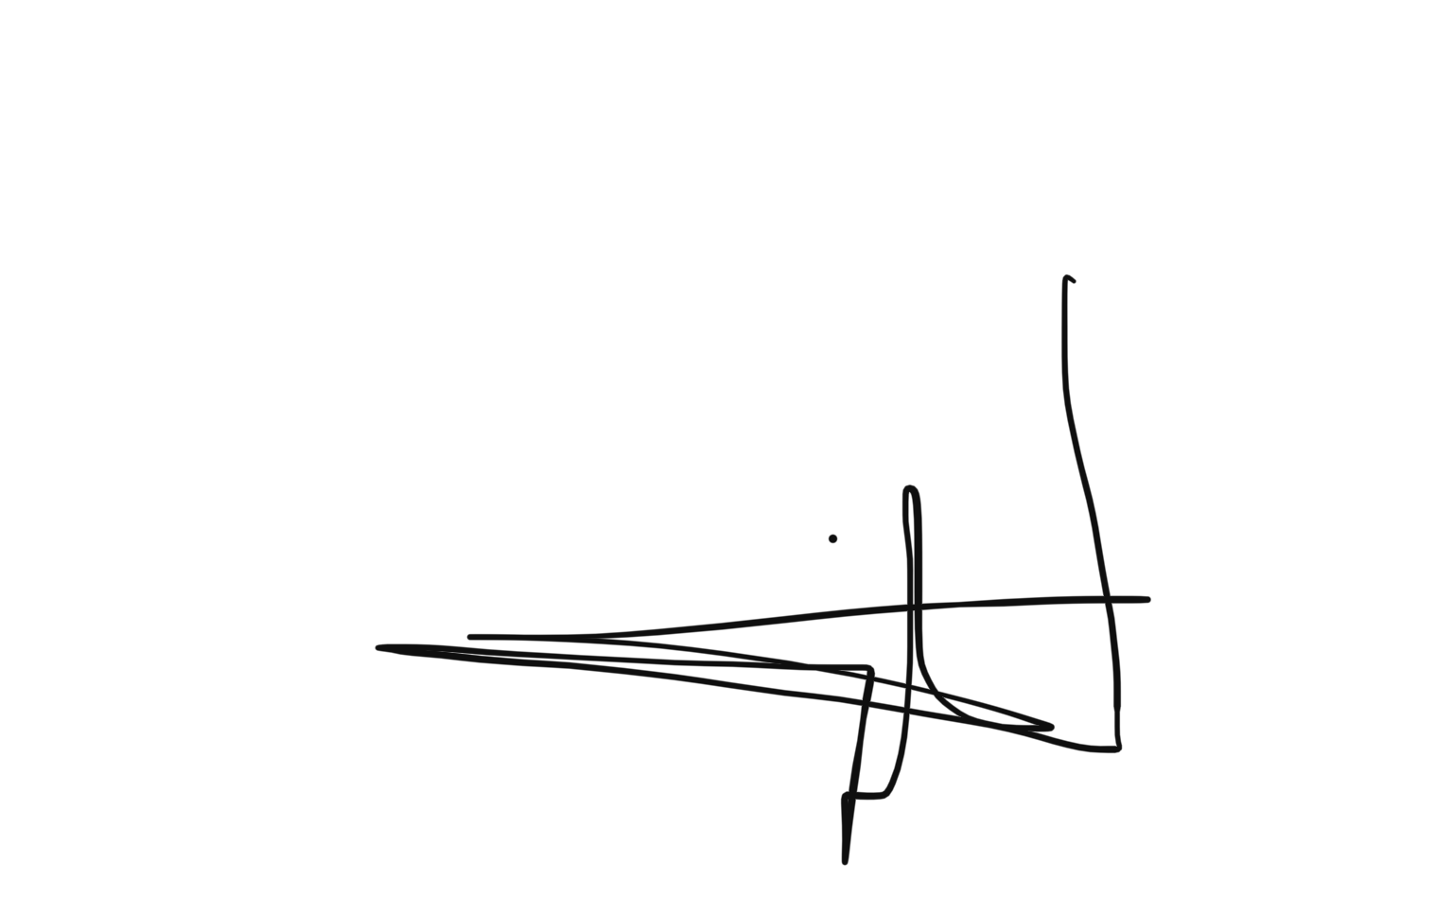
Date: | 07/05/2022
Policy review date: | 06/05/2023

